Text / String Data Types
# Source: AI Source: Provided by: [Data Path: Persons Table -> ID Column: 1, Name_En Column: Motasem Essam] -> From: [Chatgpt (GPT‑5 Mini)] on [12/10/2025]
A String is a data type used to store text.
It contains a sequence of characters, such as letters, numbers, symbols, or spaces.
Strings are usually written inside double quotes " " (sometimes single quotes depending on the language).

Examples of String Values
# Source: AI Source: Provided by: [Data Path: Persons Table -> ID Column: 1, Name_En Column: Motasem Essam] -> From: [Chatgpt (GPT‑5 Mini)] on [12/10/2025]
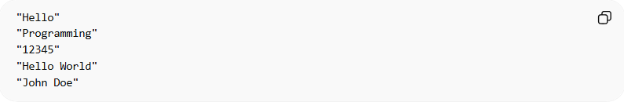
"Hello"
"Programming"
"12345"
"Hello World"
"John Doe"
Each example contains multiple characters forming text.

Example in Programming

C / C++
# Source: AI Source: Provided by: [Data Path: Persons Table -> ID Column: 1, Name_En Column: Motasem Essam] -> From: [Chatgpt (GPT‑5 Mini)] on [12/10/2025]
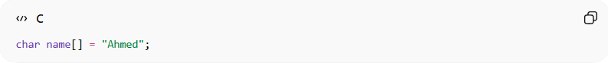
char name[] = "Ahmed";

Java
# Source: AI Source: Provided by: [Data Path: Persons Table -> ID Column: 1, Name_En Column: Motasem Essam] -> From: [Chatgpt (GPT‑5 Mini)] on [12/10/2025]
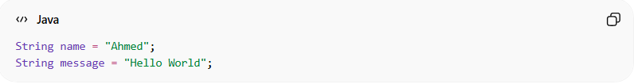
String name = "Ahmed";
String message = "Hello World";

Python
# Source: AI Source: Provided by: [Data Path: Persons Table -> ID Column: 1, Name_En Column: Motasem Essam] -> From: [Chatgpt (GPT‑5 Mini)] on [12/10/2025]
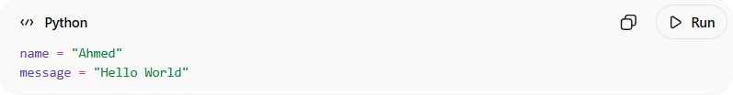
name = "Ahmed"
message = "Hello World"

Key Characteristics
# Source: AI Source: Provided by: [Data Path: Persons Table -> ID Column: 1, Name_En Column: Motasem Essam] -> From: [Chatgpt (GPT‑5 Mini)] on [12/10/2025]
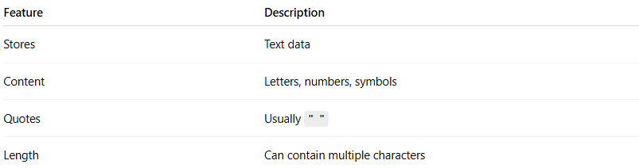
Feature | Description
Stores | Text data
Content | Letters, numbers, symbols
Quotes | Usually " "
Length | Can contain multiple characters

Example Use Case
# Source: AI Source: Provided by: [Data Path: Persons Table -> ID Column: 1, Name_En Column: Motasem Essam] -> From: [Chatgpt (GPT‑5 Mini)] on [12/10/2025]
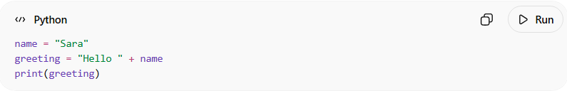
name = "Sara"
greeting = "Hello " + name
print(greeting)
Output:
Hello Sara

Common String Operations
# Source: AI Source: Provided by: [Data Path: Persons Table -> ID Column: 1, Name_En Column: Motasem Essam] -> From: [Chatgpt (GPT‑5 Mini)] on [12/10/2025]
String operations are actions performed on text (strings) in programming.

1. Concatenation (Joining Strings)
# Source: AI Source: Provided by: [Data Path: Persons Table -> ID Column: 1, Name_En Column: Motasem Essam] -> From: [Chatgpt (GPT‑5 Mini)] on [12/10/2025]
Combines two or more strings into one.
Example:
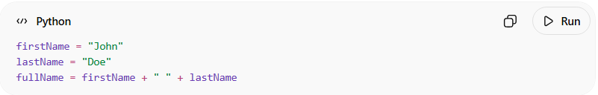
firstName = "John"
lastName = "Doe"
fullName = firstName + " " + lastName
Result:
John Doe

2. Length of String
# Source: AI Source: Provided by: [Data Path: Persons Table -> ID Column: 1, Name_En Column: Motasem Essam] -> From: [Chatgpt (GPT‑5 Mini)] on [12/10/2025]
Finds the number of characters in a string.
Example:
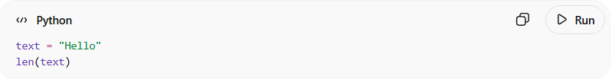
text = "Hello"
len(text)
Result:
5

3. Accessing Characters (Indexing)
# Source: AI Source: Provided by: [Data Path: Persons Table -> ID Column: 1, Name_En Column: Motasem Essam] -> From: [Chatgpt (GPT‑5 Mini)] on [12/10/2025]
Retrieves a specific character from a string using its position.
Example:
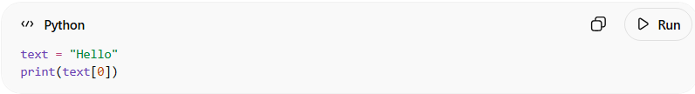
text = "Hello"
print(text[0])
Result:
H
Positions start from 0.
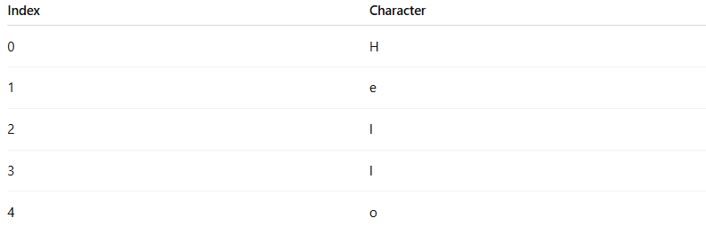
Index | Character
0 | H
1 | e
2 | l
3 | l
4 | o

4. Substring (Extracting Part of a String)
# Source: AI Source: Provided by: [Data Path: Persons Table -> ID Column: 1, Name_En Column: Motasem Essam] -> From: [Chatgpt (GPT‑5 Mini)] on [12/10/2025]
Gets a portion of a string.
Example:
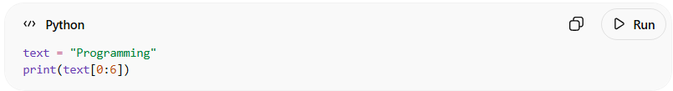
text = "Programming"
print(text[0:6])
Result:
Progra

5. Converting Case
# Source: AI Source: Provided by: [Data Path: Persons Table -> ID Column: 1, Name_En Column: Motasem Essam] -> From: [Chatgpt (GPT‑5 Mini)] on [12/10/2025]
Change the letter case of a string.
Example:
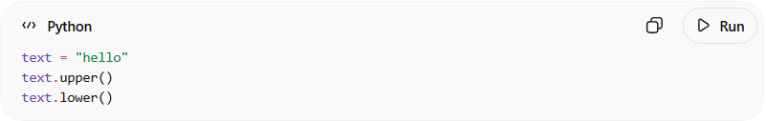
text = "hello"
text.upper()
text.lower()
Results:
HELLO
hello

6. Searching in a String
# Source: AI Source: Provided by: [Data Path: Persons Table -> ID Column: 1, Name_En Column: Motasem Essam] -> From: [Chatgpt (GPT‑5 Mini)] on [12/10/2025]
Finds whether a word or character exists in a string.
Example:
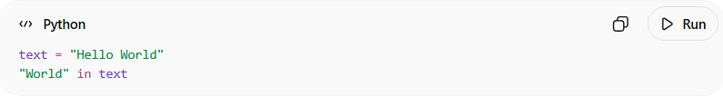
text = "Hello World"
"World" in text
Result:
True

7. Replacing Text
# Source: AI Source: Provided by: [Data Path: Persons Table -> ID Column: 1, Name_En Column: Motasem Essam] -> From: [Chatgpt (GPT‑5 Mini)] on [12/10/2025]
Replaces part of a string with another value.
Example:
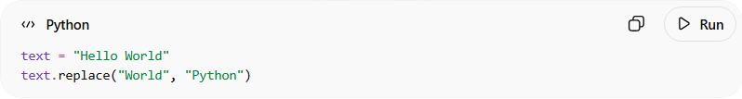
text = "Hello World"
text.replace("World", "Python")
Result:
Hello Python

8. Splitting a String
# Source: AI Source: Provided by: [Data Path: Persons Table -> ID Column: 1, Name_En Column: Motasem Essam] -> From: [Chatgpt (GPT‑5 Mini)] on [12/10/2025]
Breaks a string into a list of smaller strings.
Example:
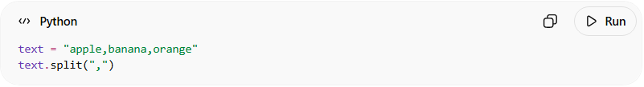
text = "apple,banana,orange"
text.split(",")
Result:
['apple', 'banana', 'orange']

9. Trimming (Removing Spaces)
# Source: AI Source: Provided by: [Data Path: Persons Table -> ID Column: 1, Name_En Column: Motasem Essam] -> From: [Chatgpt (GPT‑5 Mini)] on [12/10/2025]
Removes extra spaces from the beginning or end.
Example:
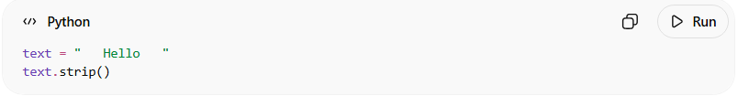
text = " Hello "
text.strip()
Result:
Hello

10. Comparing Strings
# Source: AI Source: Provided by: [Data Path: Persons Table -> ID Column: 1, Name_En Column: Motasem Essam] -> From: [Chatgpt (GPT‑5 Mini)] on [12/10/2025]
Checks if two strings are equal.
Example:
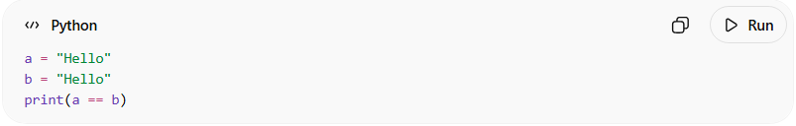
a = "Hello"
b = "Hello"
print(a == b)
Result:
True

Summary of Common String Operations
# Source: AI Source: Provided by: [Data Path: Persons Table -> ID Column: 1, Name_En Column: Motasem Essam] -> From: [Chatgpt (GPT‑5 Mini)] on [12/10/2025]
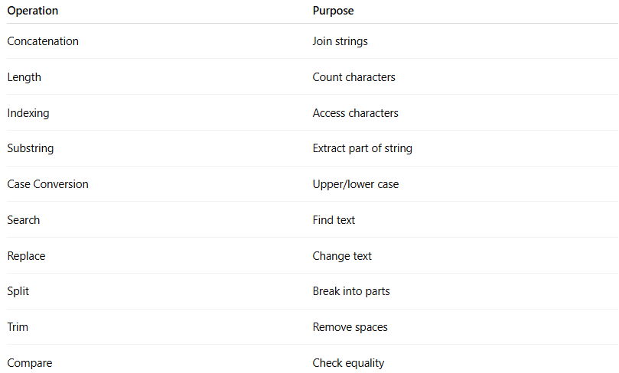
Operation | Purpose
Concatenation | Join strings
Length | Count characters
Indexing | Access characters
Substring | Extract part of string
Case Conversion | Upper/lower case
Search | Find text
Replace | Change text
Split | Break into parts
Trim | Remove spaces
Compare | Check equality

If you want, I can also show you the Top 15 String Functions programmers use most, which is often asked in programming exams and interviews.

Difference Between char and string
# Source: AI Source: Provided by: [Data Path: Persons Table -> ID Column: 1, Name_En Column: Motasem Essam] -> From: [Chatgpt (GPT‑5 Mini)] on [12/10/2025]
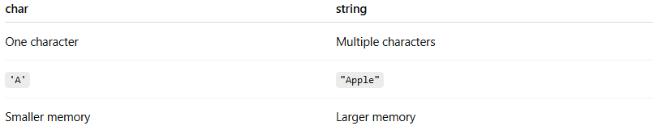
char | string
One character | Multiple characters
'A' | "Apple"
Smaller memory | Larger memory

Real-World Examples of Strings
# Source: AI Source: Provided by: [Data Path: Persons Table -> ID Column: 1, Name_En Column: Motasem Essam] -> From: [Chatgpt (GPT‑5 Mini)] on [12/10/2025]
Strings are used to store:
- Names
- Addresses
- Emails
- Messages
- Passwords
- File names
Example:
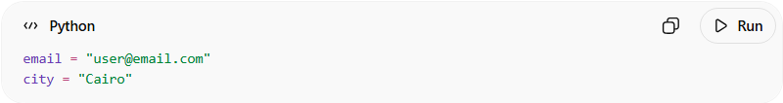
email = "user@email.com"
city = "Cairo"

